
Government College of Arts, Science and Commerce
Sanquelim-Goa
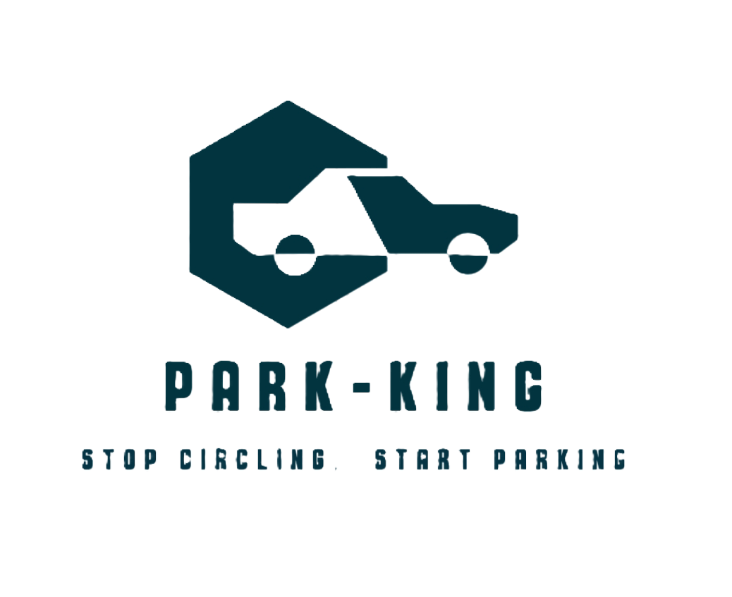
Submitted to

Goa University
in partial fulfillment for the award of the degree of Bachelor of Science (Computer Science)

February 2025
Final Year Project Report

PARK-KING
Stop Circling, Start Parking

Submitted to
Goa University in partial fulfillment for the award of the degree of
Bachelor of Science (Computer Science)

Submitted by (students):
An Maria Byju
Prajyot Sushant Salelkar
Sampada Atmaram Kelkar
Saloni Devidas Karapurkar
Pradnya Gajanan Ghad

Under the Guidance of
Ms. Pooja Naik
Assistant Professor
Department of Computer Science
Government College of Arts, Science & Commerce, Sanquelim, Goa
Academic Year
2024-25

GOVERNMENT COLLEGE OF ARTS, SCIENCE AND COMMERCE SANQUELIM GOA
C E R T I F I C A T E

This certificate is presented to:
Prajyot Sushant Salelkar
Sampada Atmaram Kelkar
An Maria Byju
Saloni Devidas Karapurkar
Pradnya Gajanan Ghadi

This is to certify that, this project entitled “PARK-KING: stop circling, start parking” is an authentic record of the work done by the above students under my guidance during their final year in B. Sc. Computer Science. And that, to the best of my knowledge the work carried out is original and has not been submitted in part or as a whole for the award of any degree or diploma in Goa University or elsewhere.
Date: 25th February 2025
Place: Sanquelim Goa

_____________________
External Examiner
Name:

_____________________
Ms. Pooja Naik
Assistant Professor
Department of Computer Science
Government College of Arts, Science and Commerce
Sanquelim-Goa

D E C L A R A T I O N

We, the undersigned, hereby declare that the project report entitled “PARK-KING: Stop Circling, Start Parking” submitted to Goa University is an original work carried out by us as part of the Bachelor of Science (Computer Science) program at Government College of Arts, Science, and Commerce, Sanquelim, Goa.
This project has been completed under the guidance of Ms. Pooja Dalvi, Assistant Professor, Department of Computer Science. To the best of our knowledge, this work has not been submitted previously for any degree, diploma, or certification at this or any other institution.
All information, data, and content presented in this report have been collected, analyzed, and compiled with due diligence, and any references to existing work have been properly cited. We declare that the presented work is conceived, executed and documented equally by all the members and the order of names that appear in the report does not represent any authorship hierarchy.
Class : T.Y.B.Sc. (Computer Science)
Submitted by:
CUIN | Name | Signature
2203631 | Prajyot Sushant Salelkar
2203669 | Sampada Atmaram Kelkar
2203727 | An Maria Byju
2203760 | Pradnya Gajanan Ghadi
2203770 | Saloni Devidas Karapurkar

A C K N O W L E D G M E N T

The successful completion of this project, “PARK-KING: Stop Circling, Start Parking” has been a journey of dedication, teamwork, and perseverance. We are grateful to everyone who has supported us throughout this process.
We extend our sincere gratitude to Prof. (Dr.) Namdev M. Gawas, Principal, for providing us with the platform to work on this project. We also acknowledge Ms. Shubha Kamat, Head of the Department of Computer Science, and our project guide, Ms. Pooja Naik, Assistant Professor, Department of Computer Science, for their time and for allowing us to undertake this project.
A special thanks to our families and friends for their constant encouragement, patience, and motivation, which played a crucial role in helping us complete this project successfully.
Finally, we appreciate everyone who contributed, directly or indirectly, to the completion of this project.

Prajyot Sushant Salelkar  (2203631) | Saloni Devidas Karapurkar  (2203770)
Sampada Atmaram Kelkar  (2203669) | Pradnya Gajanan Ghadi  (2203760)
An Maria Byju
(2203727)

A B S T R A C T

Our world presents a lot of issues, most of which are in the process of being solved due to the advances in IoT and AI, as well as several other fields. Yet, a significant problem concerning transportation is parking. According to a report by IBM, an average Indian spends around 20 minutes searching for a car parking spot, thus wasting work hours and ruining schedules. This project optimizes parking efficiency by allowing the user to easily find an open spot within minutes, thereby saving time spent circling in the parking lot.

The solution is the Android application giving real-time information about parking spots. Infrared (IR) sensors at every parking spot would sense the occupied status and then send the details to the microcontroller ESP32 using the protocol HTTP REST API. It will allow scanning a QR code at the spot of choice in order to track the parking time, which also allows sending messages and storing history. This project aims to alleviate the stress while parking by easing the process itself.

C O N T E N T
1. Introduction 1
2. Literature Review 1
3. Aim and Objective 3
3.1 Problem Statement 3
3.2 Objectives 3
4. Methodology 4
4.1 Development Process 5
5. Tools and Technologies Used 7
5.1 Hardware 7
5.2 Software 9
6. Use-case Diagrams 13
6.1 Admin’s Use-case Diagram and Description 13
6.2 Normal User Use Case 14
7. Functionalities of the App 15
7.1 Selection Activity 15
7.2 Main activity 15
7.2.1 Login Fragment 15
7.2.2 Home Fragment 15
7.2.3 Profile Fragment 16
7.2.4 Scanner Fragment 16
7.2.5 Settings Fragment 16
7.2.6 Report Fragment 17
8. Control Flow Diagram 18
8.1 User login 18
8.2 Scanner 18
8.3 Report 19
8.4 Logout 20
8.5 Admin login 20
8.6 Admin Profile 21
8.7 Admin Home 21
9. App Structure 22
9.1 User Flow 22
9.2 Admin Flow 23
9.3 Screenshots 24
10. Database Design 27
10.1 Firebase Real-time Database 27
10.2 Collections 28
9.2.1 Reports 28
9.2.2 Members 28
11. Working Principle of the Smart Parking System 30
11.1 Role and app installation 30
11.2 Admin control 30
11.3 QR scanning 30
11.4 Parking slot real time updates 30
11.5 Firestore and Firebase 31
11.6 Parking Improvement 31
12. Results and Discussion 32
13. Conclusion 33
14. Future Enhancements 34
14.1 Incorporating Camera-Based Slot Detection 34
14.2 Adding a Payment System for Parking 34
14.3 Expansion to Multiple Stories & Smart City Integration 34
14.4 Reservation & Pre-Booking for Smart Parking Enhancement 34
15. References 35

Introduction
Large parking lots in companies, malls, and other large structures are usually plagued with problems like traffic, disorientation and wastage of time looking for empty spaces. Traditional parking systems use manual searching or signs, which are time-consuming and maddening. This leads to long waiting times, extra fuel usage and unnecessary traffic jams.
Park-King is a smart parking system that can be used to eliminate such problems. It will use sensors to identify whether a parking lot is empty or filled. This information will be sent to a mobile app, thereby allowing users to see empty spaces in real time. Each parking slot will also have a QR code, making it easy to identify and manage. This system will allow companies to have more control of their parking lots.
With Park-King, companies can reduce traffic in parking lots, save time for visitors and employees, and make parking easier. It will also avoid fuel wastage and pollution, allowing for a cleaner and more efficient parking system.

Literature Review
Parking congestion is a chronic urban issue, leading to greater fuel consumption, emissions, and driver frustration. Traditional parking systems do not provide real-time information, and thus inefficiencies. There has been a series of studies on the use of the Internet of Things (IoT) to develop smart parking systems that optimize space utilization, enhance user experience, and reduce traffic congestion. The current literature review also provides some of the most important findings from recent research studies on IoT-based smart parking systems. There have been a large number of studies exploring IoT-based intelligent parking systems with varying areas of emphasis in their implementation.
One of them discusses real-time sensing through sensors and cloud processing, referring to the efficiency of IoT in reducing parking search time and congestion [1]. The proposed system employs ultrasonic sensors to detect vacant parking slots and upload the information to a cloud server, which is real-time updated in terms of availability. The paper focuses on the importance of cloud computing for enhanced scalability but also questions the issue of data security and the requirement of strong encryption techniques. A different study provides a broad overview of smart parking solutions, categorizing different approaches based on hardware, software, and user applications, and describing the benefits of predictive models of parking [2].
The study recognizes the role played by artificial intelligence (AI) in parking patterns observation and prediction of space availability based on historical data. While AI-based approaches make operations more efficient, their success is dependent on the quality and quantity of data collected, and hence data management becomes an important factor. Other researchers have examined the inclusion of energy management in smart parking and proposed automated systems with minimal manual effort and power consumption optimization [3].
The current study offers an energy-saving model based on solar panels powering parking sensors with minimal dependency on traditional means of energy. Implementation of such a system can enable the attainment of sustainability goals, although with the problem of initial setup expense. The authors further discuss the necessity of integrating IoT-based parking solutions with electric vehicle (EV) charging points to support growing EV adoption. Another study contrasts different computational strategies and user interface ideas, proposing an idea where locals can sublet empty parking spots to supplement supply and reduce congestion [4].
This research assumes that a decentralized, blockchain-powered solution may provide an immutable and secure transaction process for peer-to-peer parking rentals. While this model achieves maximum space utilization and generates additional revenues for locals, regulatory concerns and user acceptance are major challenges. While these studies combined highlight the advantages of IoT in smart parking systems, they also indicate some challenges. Security threats and cloud storage vulnerabilities remain significant issues in real-time parking surveillance [1].
The lack of standardization in smart parking protocols poses integration issues between platforms [2].
The high initial infrastructure costs and implementation complexity are huge obstacles in energy management-based smart parking systems [3]. In addition, regulatory frameworks are also needed to govern peer-to-peer parking transactions in shared parking arrangements [4].

Aim and Objective

Problem Statement
Finding parking in congested urban areas is challenging, leading to frustration, fuel wastage, and increased emissions. In cities like those in India, drivers spend an average of 20 minutes searching for a spot. Existing systems lack real-time updates, causing inefficiency. This project proposes a smart parking solution via an Android app, providing real-time availability to reduce search time, enhance convenience, and improve urban mobility.

Objectives
The Smart Parking System aims to enhance parking efficiency by providing real-time monitoring, seamless user experience, and effective administration.
- Real-Time Monitoring and Data Management: The system will use IR sensors to continuously detect parking slot occupancy, with data being collected by the ESP32 microcontroller and stored in Firebase Realtime Database for instant updates. Users will be able to check parking slot availability through a user-friendly mobile app, which will display a real-time parking layout, reducing the time spent searching for a spot.

- User Interaction and Parking History Tracking: Each parking slot will have a QR code, which users must scan after parking. This will generate a notification containing the slot number, username, and timestamp, ensuring accurate tracking. Users can also view their parking history in a tabular format, while the admin will have access to all users’ parking history for better monitoring and management.

- Admin Control and Issue Reporting: Users can report parking-related issues, which will be stored in Firestore and visible only to the admin. The admin can take action by marking a slot as "Out of Service" and later restoring its availability once the issue is resolved. By optimizing parking space utilization and reducing unnecessary search time, the system also helps minimize fuel consumption and air pollution.

Methodology
Our project uses the Waterfall Model with incremental iterations. We went for this method because we had already finalized and discussed most of the features, so they were unlikely to change. But we also kept in mind that if slight changes were required, they would not create major disruptions and would be simple to manage. Our needs were specified right from the start—we chose IR sensors for sensing vehicles, ESP32 WROOM for data transmission, Firebase as the backend system, and QR codes for generating history. The Waterfall Model was best suited for us since our app is highly reliant on the IoT system. Without finishing the hardware setup, proceeding to the next phase would not have been feasible. In addition, our project did not need continuous feedback loops, so the Waterfall Model was a more structured and manageable method.

We talked about the basic requirements of our project at the beginning. We discussed whether it should be made for public or private parking spaces, how the user login would be done, if registration would be available to all or limited by an admin, what technology we would implement for vehicle detection, which microcontroller would be best, and if we should take into account multi-story parking or only a single-level system. After detailed discussions, we decided on the following main points:
- The system would concentrate on a personal parking space.
- An admin would run the system and have control, limiting access to authorized users (e.g., staff employees).
- IR sensors would determine occupied and unoccupied parking spaces.
- ESP32 WROOM would be interfaced with the sensors and send data to the database.
- Firebase was utilized as the backend since it is easy to work with and it has several benefits.
- For simplicity's sake, we'll start with a one-story parking space initially.
Our system combines both hardware and software to offer users real-time updates on parking slots. The IR sensors are constantly scanning forward and passing information to the ESP32, which passes it to Firebase for storage and processing. Firebase's real-time database updates the home fragment of the user's application in real-time. If a user flags a problem, the problem gets stored in Firestore, enabling the admin to see it on their report fragment.

The Park-King app provides the user with multiple important functionalities: observation of real-time availability of parking slots, checking history of parking, QR code scanning for slot authentication, receiving notifications, and reporting. Admins also have extra rights, including flagging slots as out of order, observing all reports, and getting access to the full history of users. The app is developed with a minimal and intuitive interface, featuring:

- Home Page: Shows the parking layout with real-time slot availability (Green = Available, Red = Occupied, Gray = Out of Service).
- Profile Page: Displays user information and parking history.
- Scanner Page: Enables users to scan QR codes to validate their parking slot.
- Reports Page (Admin Only): Shows user-reported issues; admins can act and mark slots as out of service.

Development Process
The project was built in five phases:
Phase 1: Application Structure & Login System
In the initial stage, we constructed the initial setup of the application. We formed the login activity for regular users and admins with a connection to Firebase. Admin login was made with hardcoded credentials, and common users were assigned hardcoded passwords for logging in to their accounts. We also developed the initial shape of other functionality and formed the main activity holding all the key fragments such as Home, Scanner, Profile, Settings, and Report.
Phase 2: Hardware Integration & Real-Time Updates
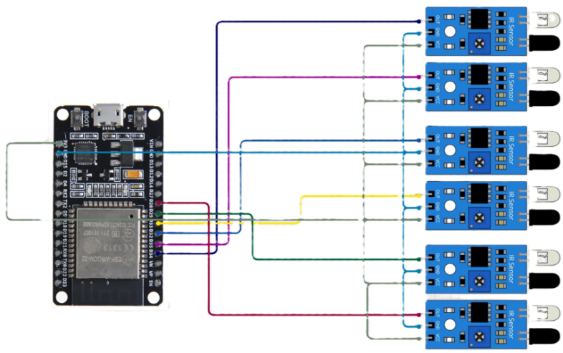
In this phase, we were dealing with hardware connections. We have connected IR sensors to ESP32 and tuned them to measure the desired distance. We have downloaded Wi-Fi and Firebase client libraries onto Arduino IDE in order to make a connection between ESP32 and the internet. First, we tested Wi-Fi connection, and once it was running smoothly, we wrote the main code for data transmission. Once we ensured the data was being reflected properly in Firebase, we linked the approximately sketched Home Fragment (for users and admin) to Firebase to show real-time updates. This phase was really troublesome since we encountered problems getting the real-time updates to show up nicely on the home screens, which took a lot of time to fix. Fig 1 represents our systems circuit.
Phase 3: QR Scanner & Notifications
During this stage, we deployed the QR scanner and notification system. For notifications, we utilized Firebase Cloud Messaging (FCM), which keeps a unique token for every user. This allows notifications to be sent to the right users depending on their activity. The notification information is also saved and displayed in the user's history, while the admin can see all notifications in an organized, tabular manner. This phase was also very challenging, primarily due to the fact that the tokens were not being stored correctly, and debugging took time.
Fig 1: smart parking system’s circuit
Phase 4: Report System
The report system was introduced in this stage. Users were given a form with two dropdown menus—one for choosing the issue type and the other for choosing the parking slot number. Users were required to fill both fields before they could submit a report. The reports were then saved in Firestore and retrieved in the Admin's Report Fragment, where the admin could view and act upon.
Phase 5: Testing, Debugging & UI Enhancements
The last phase involved testing, debugging, and enhancing the user experience of the app. We fixed bugs, enhanced UI transitions, included a splash screen, developed a logo, and fine-tuned the design overall. We also checked the Firebase connectivity so that the real-time updates are shown as they should. We also ensured if the detection range of the IR sensor was high enough for useful implementation.

Tools and Technologies Used

Hardware

ESP32 WROOM Wi-Fi Bluetooth Module
Specifications:
- Ultra-low-power consumption
- Flash Memory: 4 MB
- Current Consumption: 80 mA
- Supply Voltage: 3.0V to 3.6V
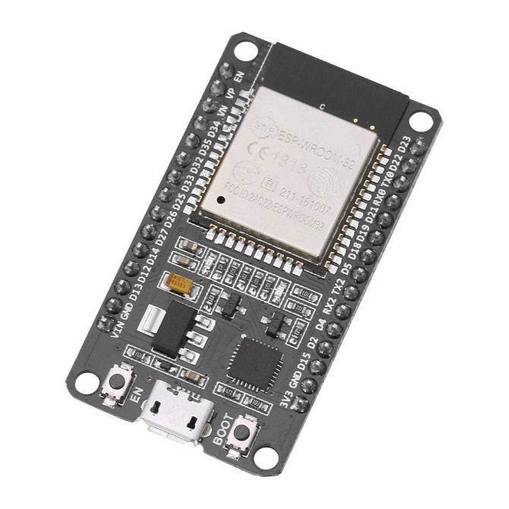
- Data Rate: 150 Mbps
- Operating Frequency: 2.4 GHz

The ESP32 WROOM (Fig: 2) development board is a highly capable, flexible board intended for various IoT applications. Based on the strong ESP32 microcontroller, it integrates Wi-Fi and Bluetooth features, providing reliable wireless connectivity in one board. The board features 30 GPIO pins, supporting various peripherals and interfaces, which makes it suitable for beginners as well as professional developers designing smart devices, home automation, and other embedded-systems.
Fig. 2: ESP32 WROOM WiFi Bluetooth Module
This module features a dual-core processor, which provides effective performance and the capability to process intricate tasks concurrently. It accommodates different communication protocols such as SPI, I2C, UART, and PWM, which facilitate seamless integration with sensors, actuators, and other electronic devices. Its small size and low power consumption make it ideal for battery-powered devices and power-efficient applications.
The ESP-WROOM-32 development board supports widely used development environments such as the Arduino IDE, MicroPython, and ESP-IDF, offering ease of development and flexibility. It has a built-in antenna for reliable wireless communication and features an integrated voltage regulator, enabling direct connection to external power supplies.
Whether you're designing a new IoT product, creating a wireless sensor network, or working on a Bluetooth-based project, the ESP-WROOM-32 provides the performance and flexibility to make your projects a reality.

Infrared (IR) Sensor in Smart Parking Systems
Specifications:
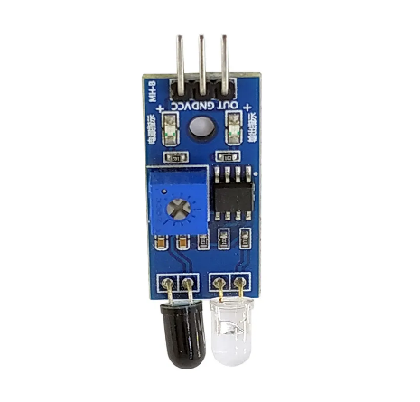
- Green Indicator Light on Circuit Board
- Detection Distance: 2–30 cm
- Detection Angle: 35°
- Comparator Chip: LM393
- 3mm Screw Holes for Easy Mounting
Fig. 3: Infra-Red Sensor
Infrared sensors (Fig: 3) are used to sense and quantify infrared radiation around them. There are two types of IR sensors: active and passive. Active IR sensors reflect infrared light off an object to sense it, while passive IR sensors sense the infrared radiation from the objects. We employ active IR sensors to sense cars in our smart parking system. IR sensors have an operating voltage of 3.3V - 12V, current draw of 10mA - 50mA, and a detection range of 2cm - 5 meters. They can operate in a wavelength range of 850nm - 950nm, have a response time of a few milliseconds, and can give either analog or digital output signals. Such sensors are applied to a large range of industries for their capacity to sense objects, measure distances, and detect heat. Some applications of such sensors include parking systems smart, security and surveillance, consumer electronics, industrial automation, healthcare and medical, robotics and IoT, agriculture and environmental monitoring, and many others. IR sensors are a very suitable option in the case of large parking systems because they are cheap, widely available, and easy to install.

They can be installed in several locations without going beyond the budget. They can also be easily incorporated into new and existing parking systems with less disruption. Due to their low power consumption, they are very efficient for long-term utilization, which means they will continue to operate over a very long duration. In the smart parking system, IR sensors detect the presence of a vehicle by measuring infrared signal reflection. When a car is present, the infrared signal is reflected back, signaling an occupied space (red). When no car is there, the reflection signifies an available space (green). The sensor sends this information to a microcontroller, which displays the parking status in real time. This system provides accurate and efficient parking control, minimizing human intervention and enhancing user convenience.

Software

Android Studio

Android Studio (Fig: 4) is the official Integrated Development Environment (IDE) for building Android applications, developed by Google. It is built on IntelliJ IDEA and features basic tools used in designing, coding, testing, and debugging apps. It is compatible with various programming languages such as Java, Kotlin, C++, and Dart (Flutter), making it a multi-programming language support platform for developing mobile apps.
Fig. 4: Android Studio
Android Studio makes app development easier with features such as code completion, syntax highlighting, and refactoring capabilities. It has an Android Emulator for testing applications on simulated devices and profiling tools to track CPU, memory, and network usage. The Gradle Build System handles dependency management, compilation, and packaging automatically, making it more efficient. It also offers logcat for debugging in real-time and built-in APK generation tools for simple deployment to the Google Play Store.

Firebase
Firebase (Fig: 5) is a cloud platform that offers backend services such as real-time data storage, authentication, hosting, cloud messaging, and analytics. It simplifies app development by managing server-side operations, allowing developers to focus on creating smooth user experiences. Firebase supports Android, iOS, and web apps through SDKs and APIs for easy integration.

Firebase provides two powerful database solutions: Real-Time Database and Cloud Firestore. The Real-Time Database stores data in JSON format and syncs updates instantly across connected devices, making it perfect for chat apps and live tracking. Cloud Firestore, an advanced NoSQL database, offers better querying, offline support, and scalability for complex applications.
Firebase also includes authentication with multiple login options such as anonymous login, email/password, and social logins (Google, Facebook, Twitter, etc.). Firebase Cloud Messaging (FCM) enables push notifications across devices for instant updates. Firebase Hosting provides fast and secure web app deployment with integrated SSL certificates and a global CDN.
Fig 5: Firebase
The following additional features make firebase and excellent tool for back-end management of applications and web technologies:
Firebase ML: Firebase ML empowers you to add powerful machine learning features to your app with ready-to-use APIs and support for custom model deployment.
Crashlytics: Crashlytics enables you to monitor and resolve stability issues in your app efficiently.
Remote Config: Remote Config allows you to carefully introduce and assess new features for stability and performance.
App Check: Firebase App Check helps protect your app from abuse by attesting that incoming traffic is coming from your app and blocking traffic without valid credentials.


Arduino Integrated Development Environment (IDE)
Arduino (Fig: 6) is an open-source electronic platform that combines hardware (microcontroller boards) and software (Arduino IDE) for interactive projects. Common boards include Arduino Uno, Mega, and Nano, featuring digital and analog pins for interfacing with sensors, motors, and other devices. The Arduino IDE allows coding in C and C++.
Fig 6: Arduino IDE
Arduino is popular for its ease of use, affordability, and versatility. Unlike other microcontrollers, it simplifies hardware programming without requiring deep electronics knowledge. Its modularity enables rapid prototyping, and its strong open-source community offers extensive tutorials, libraries, and sample codes. Arduino also supports communication protocols like WiFi, Bluetooth, and GSM, making it ideal for remote monitoring and automation.
Arduino is used in home automation (smart lighting, remote control), IoT (real-time sensor data monitoring), and robotics (drones, autonomous vehicles). It supports sensor-based systems for tracking temperature, humidity, and motion. In industrial automation, Arduino aids in machine control and predictive maintenance. It also enhances security systems through biometric access and surveillance.
With cloud integration (e.g., Firebase), Bluetooth (HC-05), and WiFi (ESP8266/ESP32), Arduino enables wireless device control. It also supports MQTT and IoT protocols for large-scale projects. Advanced applications include AI-based automation, GPS tracking, and gesture recognition.


Java
Java (Fig: 7) has been a primary programming language for Android development from the start. It's famous for being stable, simple to learn, and used extensively on various platforms. Prior to Kotlin becoming the language of choice, Java was the official language for developing Android applications, and even now, numerous applications and frameworks continue to use it
Fig 7: Java
Java-based Android applications execute on the Android Runtime (ART) or the previous Dalvik Virtual Machine (DVM), which enables them to run on various devices without changing code. Java's inherent functionalities, such as memory management and multi-threading, assist developers in building seamless and effective mobile apps.

As Java is highly integrated into Android's built-in components—including Activities, Fragments, and Services—it eases the construction of interactive and dynamic applications. It also blends well with packages like Firebase, which developers use for features like real-time databases, authentication, and cloud messaging.
Although Kotlin is now the suggested language for Android development, Java is still widely employed, particularly in older applications and by those developers who prefer it. Due to its vast community and vast documentation, Java is still a valuable and relevant language for Android development.

Use-case Diagrams

Admin’s Use-case Diagram and Description
The admin in the smart parking system fully controls user reports and parking slot management (Fig: 8). Admin logs in with static credentials and is able to observe the real-time status of all parking slots. They can update individual slot statuses manually or utilize the "Update All" option to update multiple slots at a time. Moreover, the admin also gets to see reports filed by users in case of any issue in the parking system. They can even see the parking history of all the users for record purposes and monitoring. For security purposes, the admin needs to log in each time and has the option to log out when required.
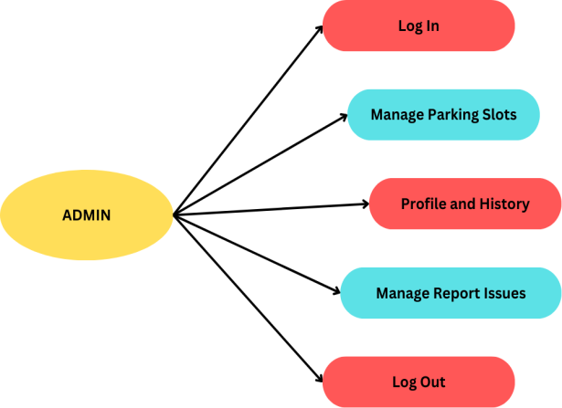
Fig 8: Admin functionalities

Normal User Use Case
In the smart parking system, a regular user logs in via assigned credentials to access their profile. They can see the live status of every parking slot in order to choose where to park. Upon parking, they use the QR code on the slot to check the information of that slot (Fig: 9). The users can access their parking history in the profile section and complain about any issue regarding the parking system through the app. For security reasons, they can log out from their account if necessary.
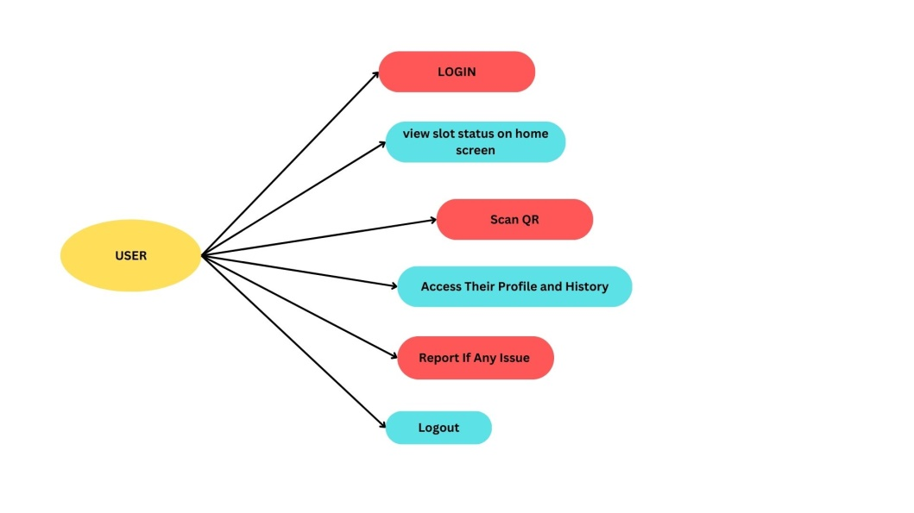

Fig 9: User functionalities

Functionalities of the App

Selection Activity
It is the initial screen that appears when the app is launched. It prompts the user to select a role—Normal User or Admin (Fig: 27). When the user chooses Normal User, they will be led to the normal user login page. When they provide correct credentials, they will be navigated to the home page, where they will be able to use all the features intended for them.
If the user chooses Admin, it will redirect him to the admin login page. The admin will have to fill in a set of predetermined credentials. If they match, he will be forwarded to the home page with features specific to admins.

Main activity

Login Fragment
The login is based on Firebase Authentication using email and password. Normal users may log in only when the admin has signed them up and given them an authorized password. Otherwise, they have no access to the features of the app (Fig: 28). They store their credentials in Firebase Authentication.
Admins log in through a fixed credential that they know alone. This will prevent unauthorized users from using the admin panel (Fig: 28).

Home Fragment
After logging in, users arrive at the home page, which has a parking layout with updates of available slots in real-time (Fig: 19). Each parking slot will show a status, which can be one of the following:
- Occupied
- Not Occupied
- Out of Service
Users may refresh the screen by clicking on the "Refresh" button to refresh the status.
For admins, the home page is the same, except with an additional feature. Admins are able to modify the status of any slot by clicking on it. A dialog box will pop up, which they can use to select either "Not Occupied" or "Out of Service." If an admin does update a slot, the admin will see the change on their screen as will all regular users. A toast message will notify the update was successful with "Update Successful." (Fig: 23)

Profile Fragment
For normal user, the profile fragment consists of two sections. The first section displays the user's email and username, allowing them to edit their name as per their preference. The second section presents their parking history in a tabular format, showing the date, time, and slot number of each parking event (Fig: 21).
For admin, the first section of the admin profile is identical to that of regular users, displaying the email and username with the option to edit the name. However, the second section differs as it displays the parking history of all users instead of just personal records. This allows admins to track which user parked in which slot, enabling better monitoring and management of the parking system (Fig: 24).

Scanner Fragment
The scanner function is only accessible to regular users. They can use it to scan the QR code of the parking lot where they parked their car. After scanning the QR code successfully, the result will be shown on the screen. The user will also be sent a push notification with the parking time and slot number as a confirmation. The information will be saved in Firebase so that users can view their parking history at a later time (Fig: 20).

Settings Fragment
The settings page includes a reporting feature and a logout button. If a user faces a parking issue, they can report it to the admin. To successfully submit a report, users must select both the issue type and slot number; otherwise, a toast message will prompt them to fill in the required fields. The slot selection feature ensures faster and more efficient issue resolution. The logout button redirects the user to the selection page(Fig: 22).
The admin settings page contains only a logout button, which functions the same way as for regular users, redirecting them to the selection page upon logging out (Fig: 2).

Report Fragment
This feature is exclusive to admins, allowing them to view reports submitted by users in real-time (Fig: 25). Each report includes the issue type, slot number, user email, and timestamp. When a user submits a report, it is stored in Firebase Firestore and instantly reflected in the admin’s report fragment. These reports help admins take necessary actions as needed. "Additionally, the admin can manually refresh the fragment by pulling it down and releasing it."

Control Flow Diagram

User login
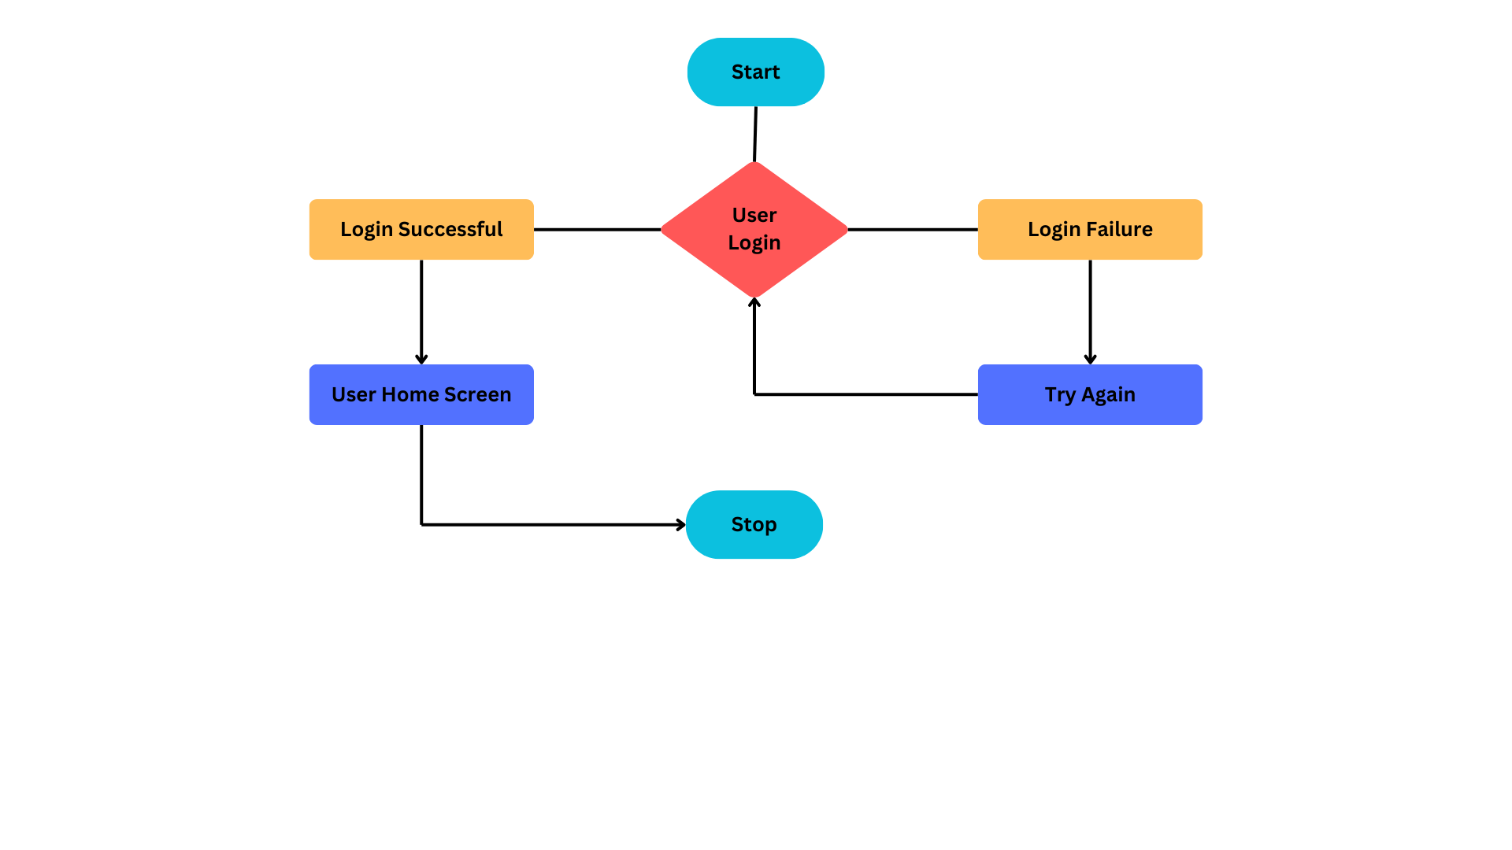
Fig 9: User Login Control flow
User login is the central step through which the user can access the application(Fig: 9) . The user inputs their provided credentials, and if they are correct, they get access. If not, they are prompted to try again with the right credentials

Scanner
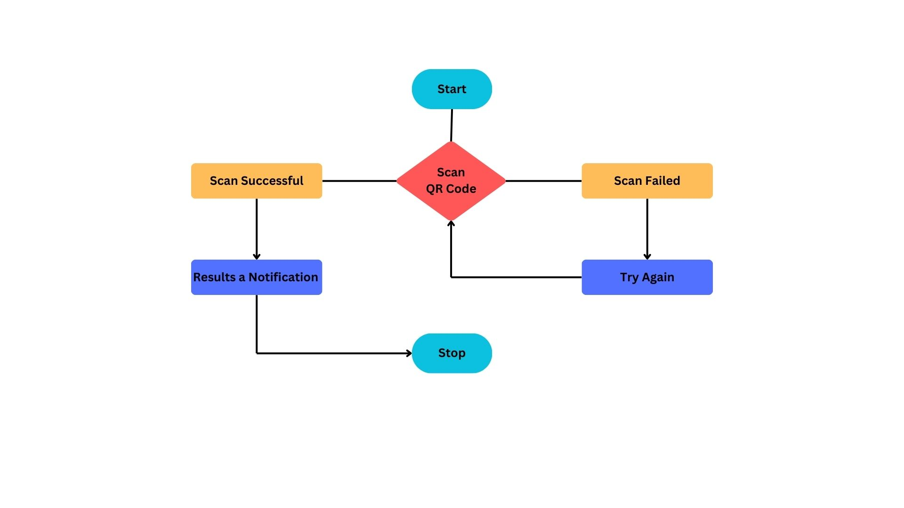
Fig 10: User Scanner Control flow
Once user scan the QR code (Fig: 10), user will get one notification that will contain date, time and slot number.
Profile
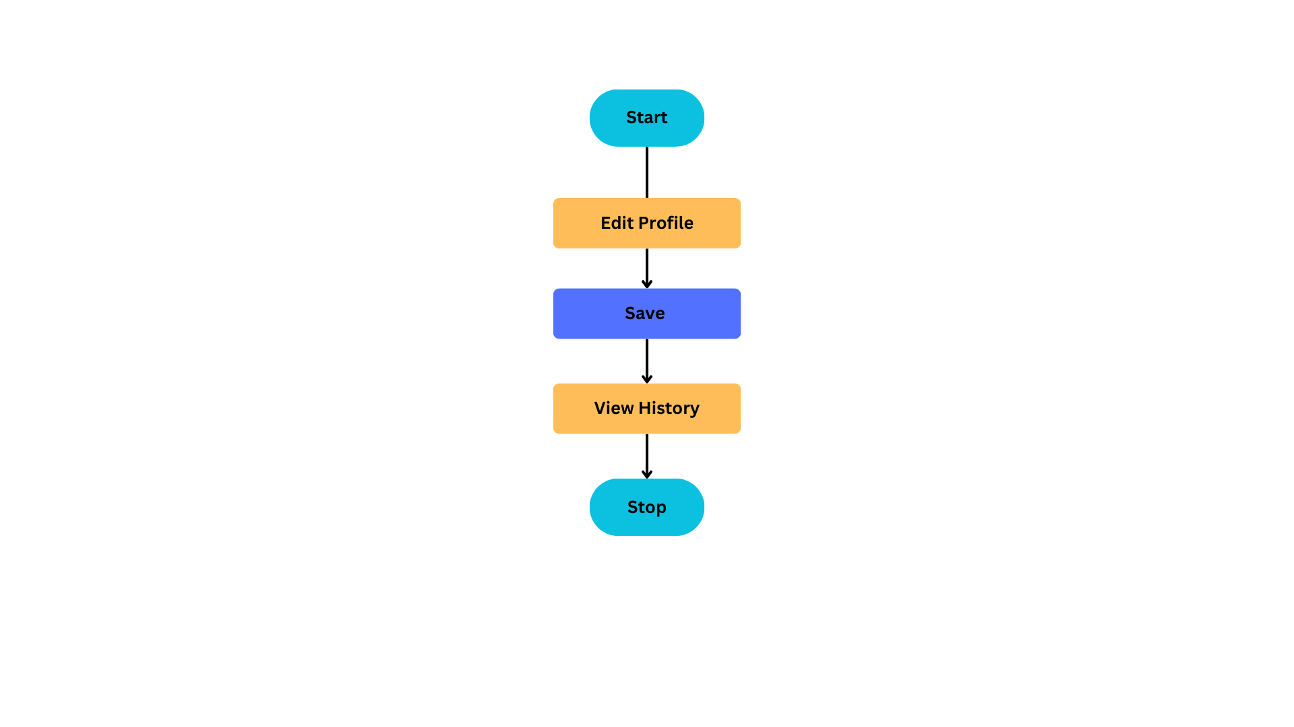
User will be able to edit their user_name and save it (Fig: 11). The profile will also contain their history. This history will be stored with the help of notifications.

Fig 11: User Profile Control flow

Report
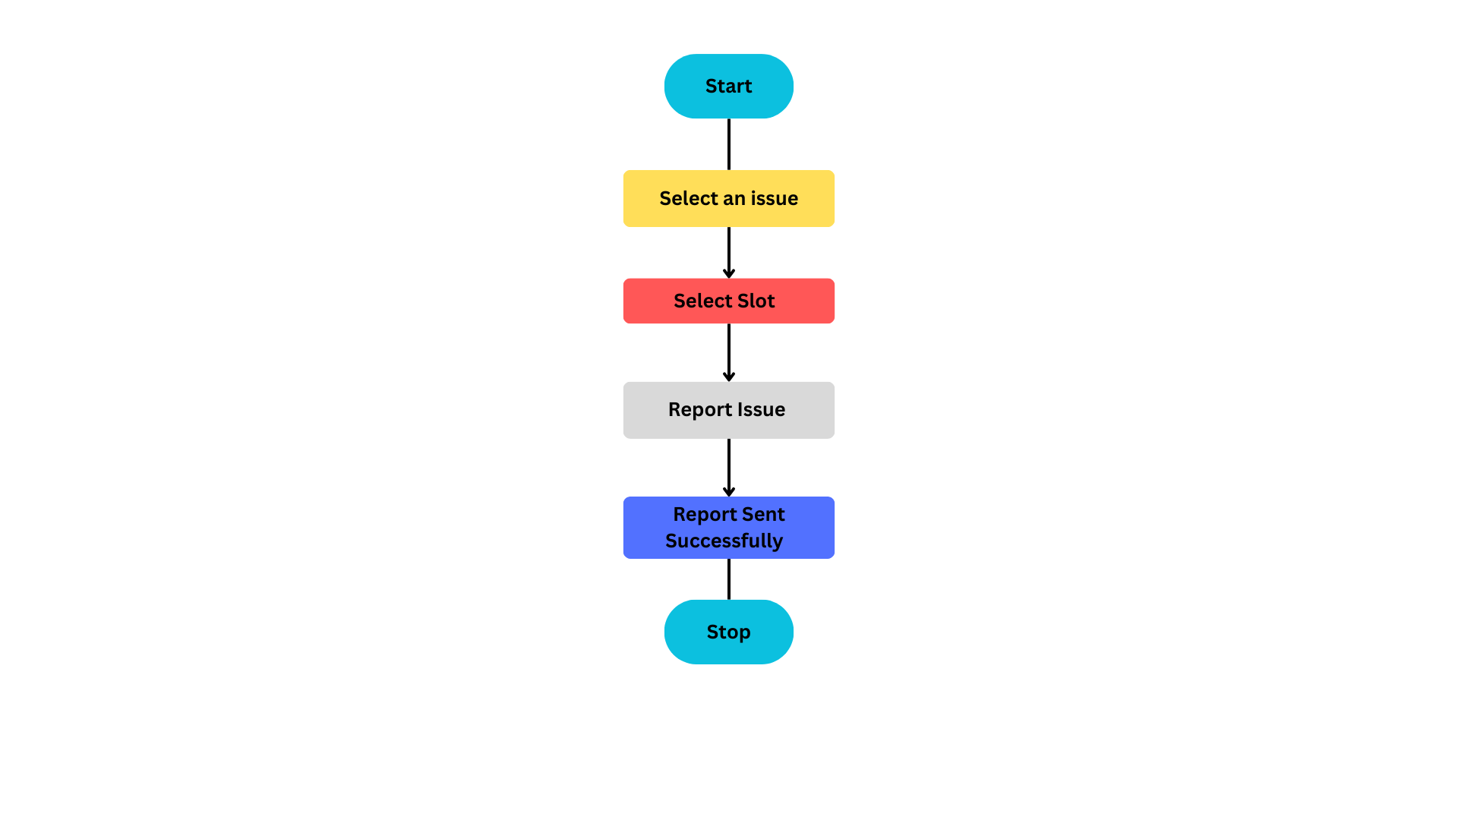
Fig 12: User Report Control flow
User login is the central step through which the user can access the application (Fig: 12). The user inputs their provided credentials, and if they are correct, they get access. If not, they are prompted to try again with the right credentials

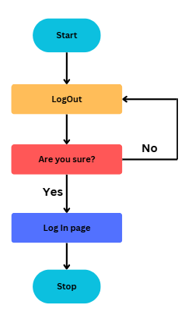
Logout
You may logout from the application by using the logout button on the settings screen (Fig: 13) . After clicking the button, a pop-up window with the question, 'Are you sure?' will be displayed. If the user clicks 'Yes,' the user will be taken to the selection page. If the user clicks 'No,' they will stay on the settings screen.
Fig 13: User Logout Control flow

Admin login
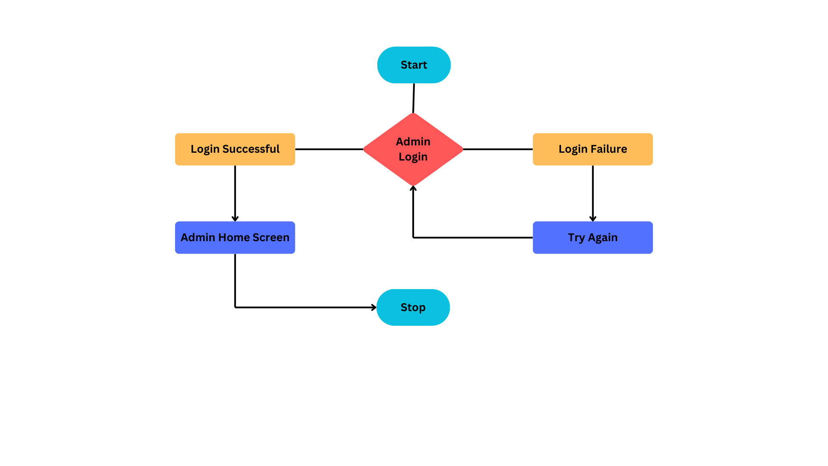
Admin login is the central step through which the user can access the application (Fig: 14). The admin inputs their provided credentials, and if they are correct, they get access. If not, they are prompted to try again with the right credentials.
Fig 14: Admin Login Control flow

Admin Profile

The admin will be able to edit their username and save it (Fig: 15). The profile will also contain the history of all users. When any user scans a particular slot's QR code, their history will be shown here.

Fig 15: Admin Profile Control flow

Admin Home
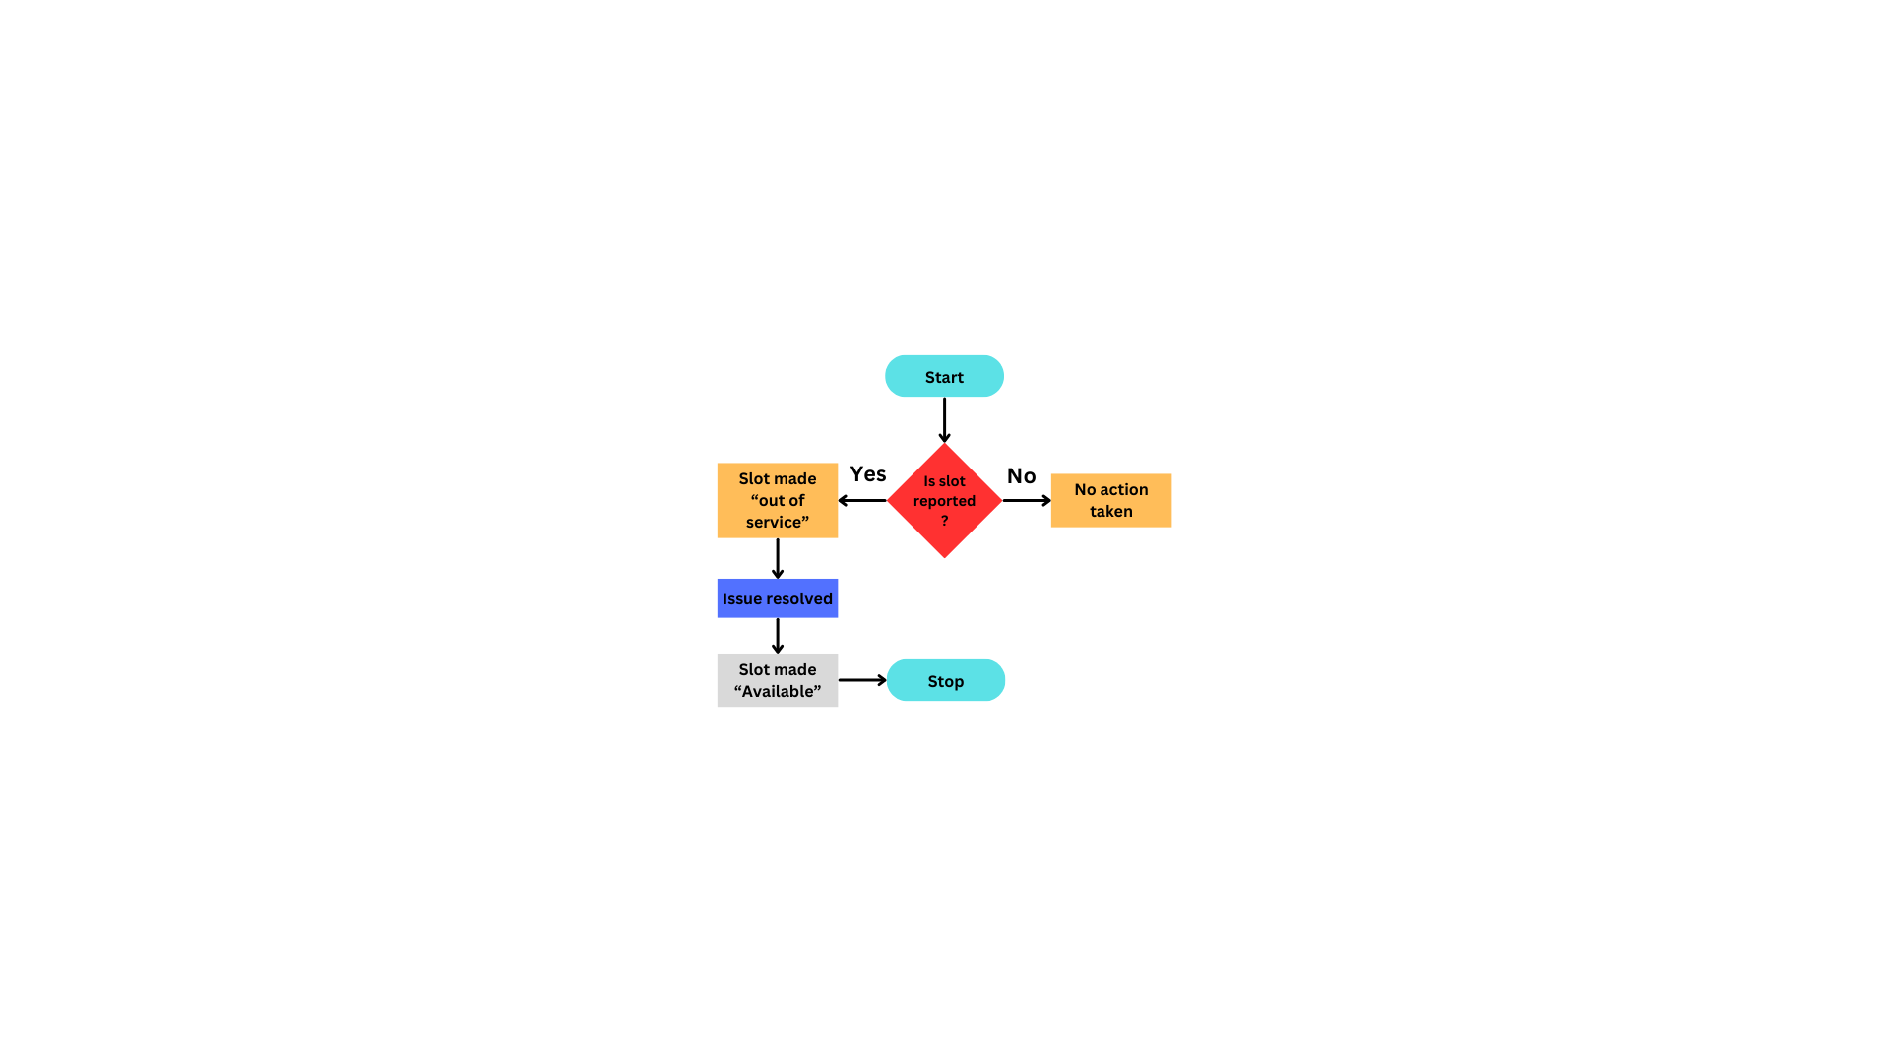
Fig 16: Admin Home Control flow
The admin will be capable of modifying the status of slots if a problem is encountered with respect to them (Fig: 16). The admin will be able to tag any place as "Out of Service" or "Available" according to necessity.

App Structure

User Flow
The process begins with the selection of the role of the user on the selection screen (Fig: 17). Once the 'Normal User' is chosen, it leads to the user login screen. If the admin-provided email and password are entered, then they are allowed to view their account. If not, then they are requested to retry. After getting logged in, they can view real time slot status, scan the QR code, submit report, and view history.
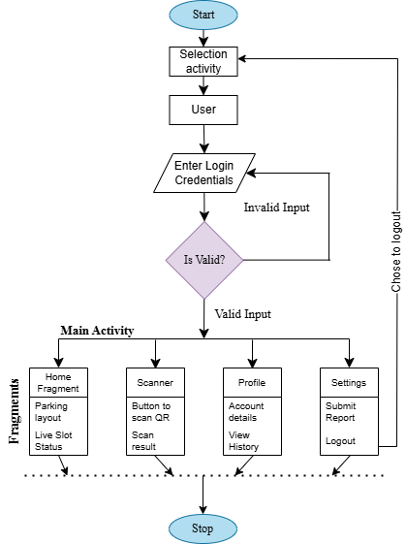
Fig 17: Users App structure

Admin Flow
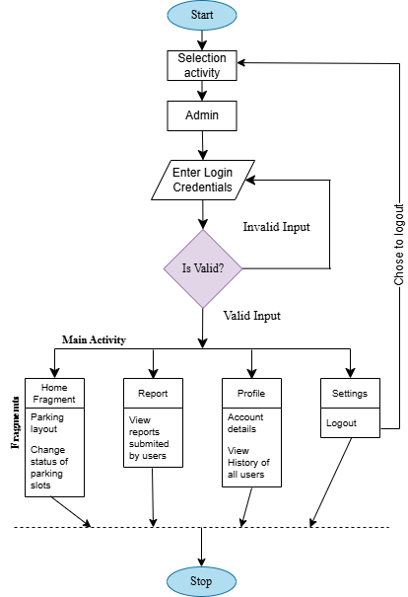
The process begins with the admin choosing their role on the selection page (Fig: 18). After they choose the 'Admin' role, they are taken to the admin login page. If they provide the proper fixed credentials, they can be taken to the admin account. Otherwise, they are prompted to try again. After logging in, the admin can manage parking slots, check reports, and view user history through the provided functionalities of the application.
Fig 18: Admin App structure

Screenshots

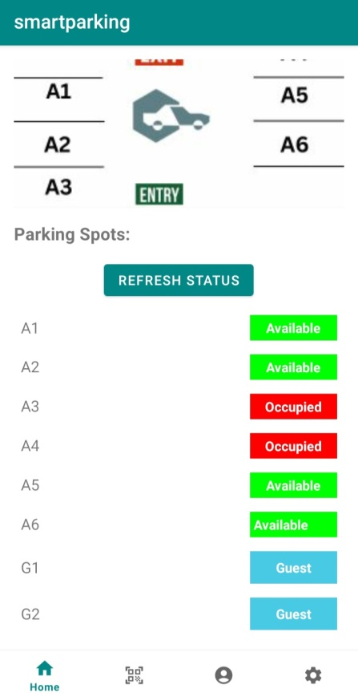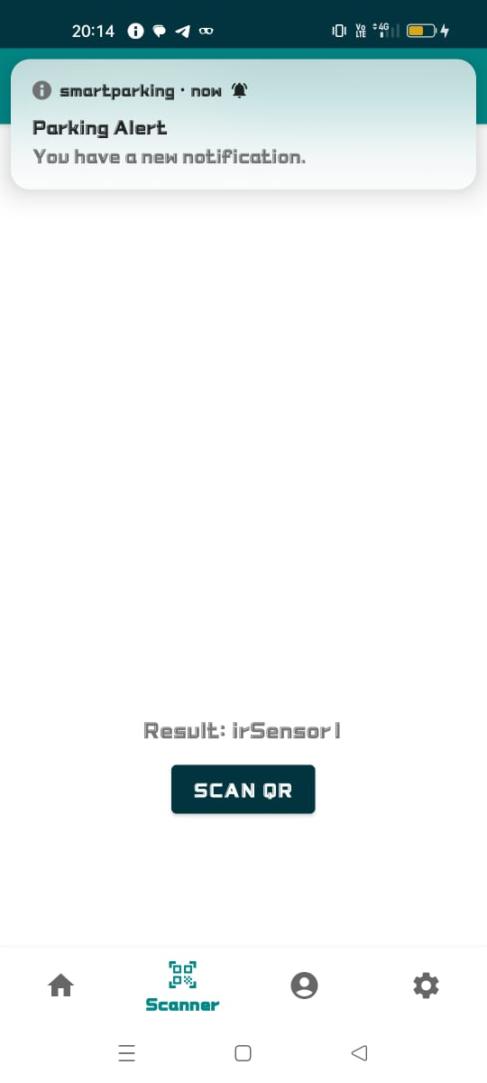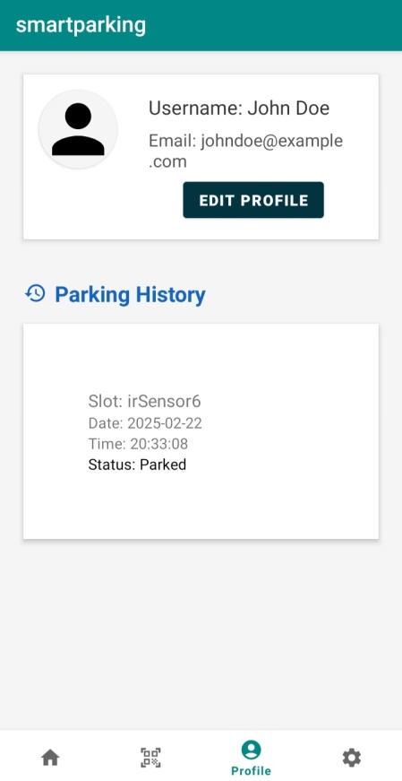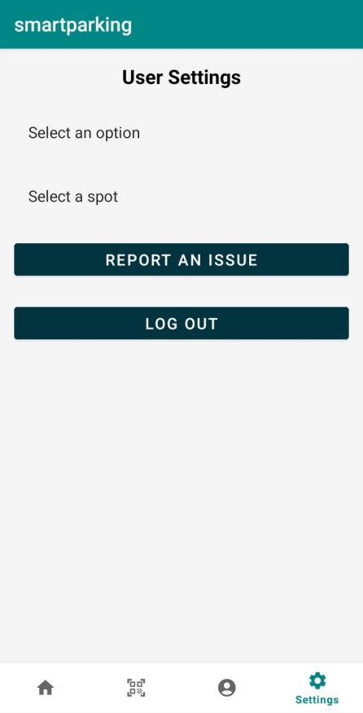
Fig 22: screenshot of user Settings
Fig 21: screenshot of user Profile
Fig 20: screenshot of user Scanner
Fig 19: screenshot of user Home

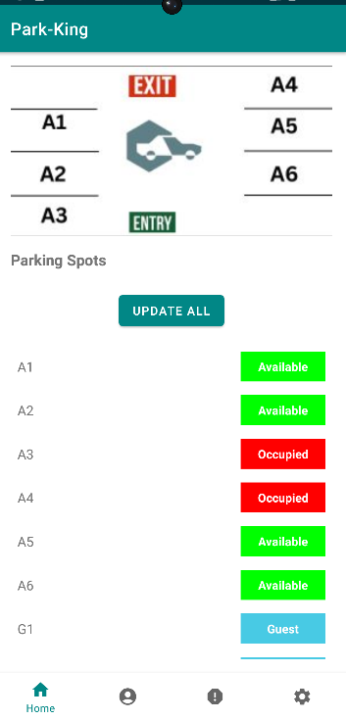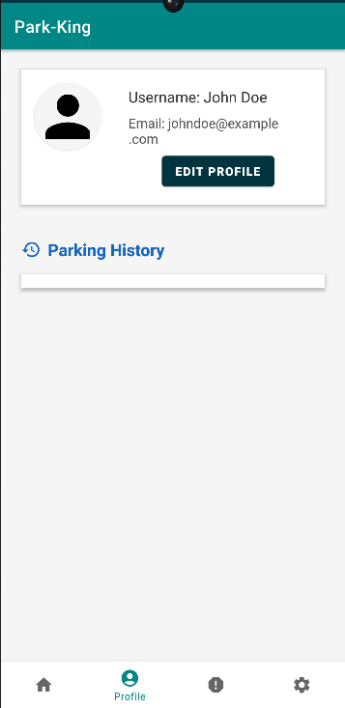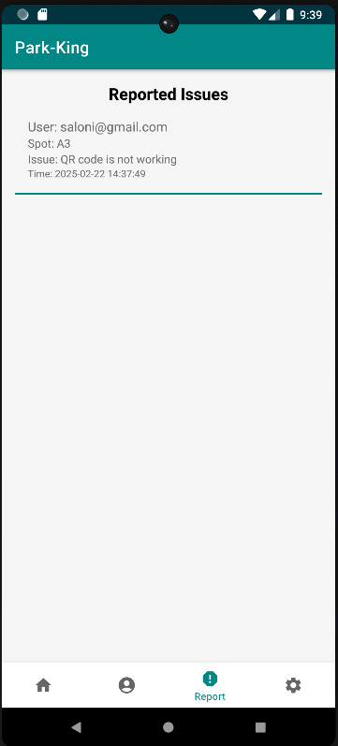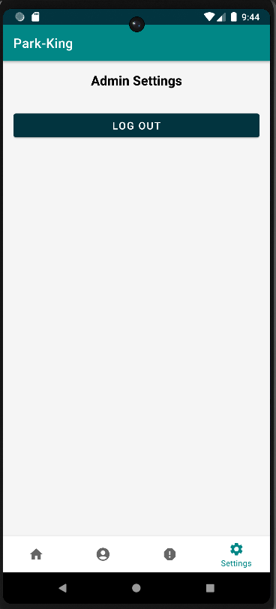
Fig 25: screenshot of admin Report
Fig 24: screenshot of admin Profile
Fig 23: screenshot of admin Home
Fig 26: screenshot of admin Settings

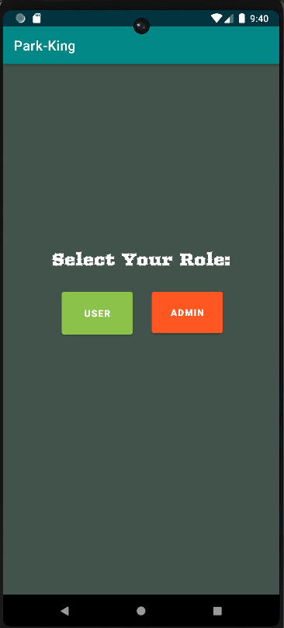
Fig 27: screenshot of selection activity

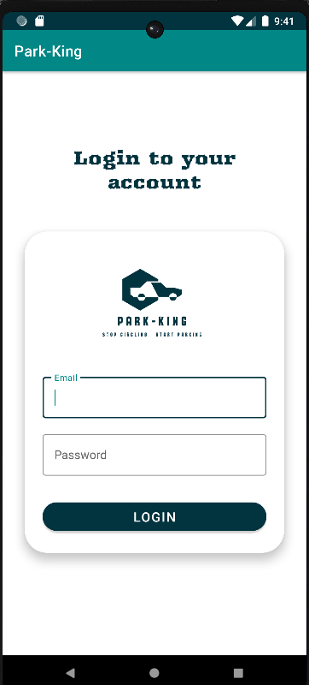

Fig 28: screenshot of Login (admin and user)

Database Design
Following collection and real-time database structures are used to store the data generated by the sensors, normal users and the admin.

Firebase Real-time Database
When the status is 'Not Detected' or 'Detected', the status is made 'False' (Fig: 29). But if the status is modified to 'Out of Service' by the admin, the locked value gets modified to 'True'. This 'True' locked value prevents the real-time updates from being updated in Firebase until the admin marks the slot 'Available'.
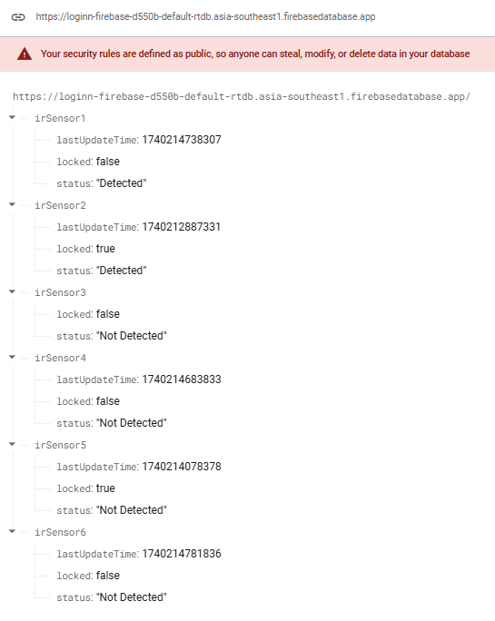
Fig 29: Firebase Real-Time Database structure

Collections

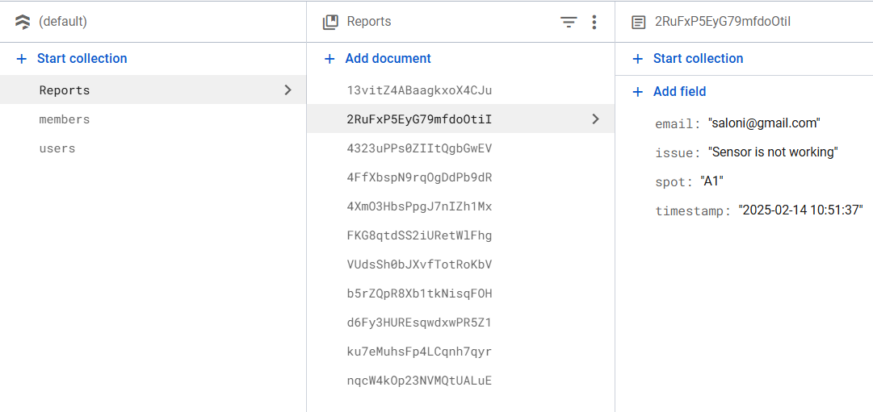
Reports
Fig 30: Report collection structure
The report collection will collect all the reports filled by the normal users and they will be made available to the admin in their report fragment (Fig: 30).

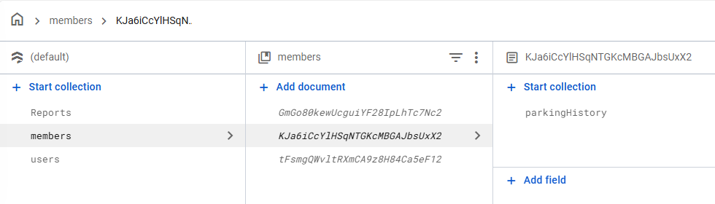
Members

Fig 31.1: Members collection structure

Fig 30.2: Members collection structure
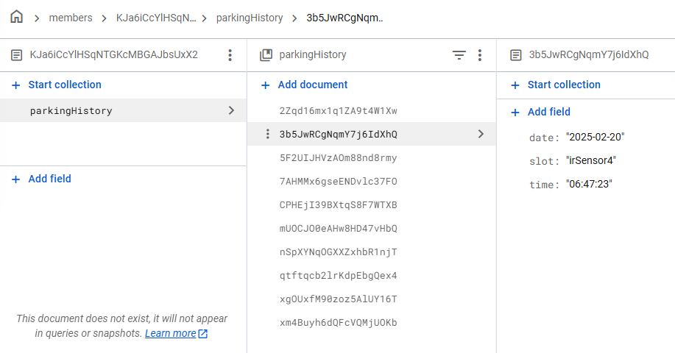
Fig 31.2: Members collection structure

This collection stores the data generated by their user after scanning the QR code of a particular slot in the parking area. The data can be seen by the users in their profile (Fig: 31.2, 31.2).

Working Principle of the Smart Parking System

Role and app installation
Once the app is installed, users are required to select their role as User or Admin. Admins control the parking system, while users find and book parking slots. On login, the system verifies the user's role from Firebase and directs to the appropriate home page. The role-based system increases security and convenience of parking management.

Admin control
Parking slots are completely controlled by the admins, where they can view live availability, indicate slots as under construction, and monitor parking activity and reports. If maintenance is required, the admin chooses the slot on the app, and the status will automatically be updated in Firebase Realtime Database. This will immediately be visible to users' eyes, so they cannot park where they cannot and promote efficient parking protocols.

QR scanning
Every parking space is assigned a unique QR code, and customers scan via the app in order to book their parking. The app fetches slot information from Firestore, and if the slot is free, the customer finalizes the parking, marking the slot as booked. The system provides access only via authorized channels with a contactless, secure, and convenient parking experience.

Parking slot real time updates
IR sensors and ESP32 monitor car presence and report slot status in real time. Sensor data is read by ESP32 and uploaded to Firebase, which updates instantly on the app. Slot statuses are represented in color: green for available, red for occupied, and gray for construction. This enables users to ask about parking availability prior to arrival and removes the need for admins to manually verify slot statuses, decreasing congestion and wait times.

Firestore and Firebase
The app uses Firestore for structured data, such as user information, QR codes, and reported problems, and Firebase Realtime Database to update slot status in real-time. Having two databases ensures efficient storage of data, quick retrieval, and synchronization of parking status updates with user activity.

Parking Improvement
To customers, the platform avoids the bother of parking searching by presenting quick slot availability and easy QR-booked arrangements. Admins benefit from having just one system management that renders administration of parking operation, reservation of slots for repair, and access to reports relatively effortless. Such a converged solution offers unified, streamlined, and organized parking facilities to everyone concerned.

Results and Discussion
In the current offline system, parking slot management and user history tracking are inefficient. There is no centralized method for users to check real-time parking availability, and admins must manually monitor slot statuses and reported issues. Additionally, users do not receive instant updates regarding their parking history or slot availability. This manual process leads to delays and inefficiencies in parking management.

The Smart Parking System addresses these limitations by introducing the following improvements:
- Users can check parking slot availability in real time through the app, eliminating the need for manual verification.
- Slot statuses, including availability and maintenance, are automatically updated.
- Admins can mark slots as "Out of Service" or "Available" based on reported issues, streamlining management.
- Users receive instant notifications upon scanning QR codes, allowing them to maintain an accurate parking history.
- All user parking history is stored in the system and accessible within the app.
- Admins have access to a centralized dashboard to monitor slot statuses, view reports, and track user activity efficiently.

By implementing this system, parking management becomes more organized, automated, and accessible for both users and administrators.

Conclusion
The Smart Parking System effectively addresses the inefficiencies of traditional parking management using the integration of IoT technology, real-time processing of data, and a user-friendly mobile app. Utilizing IR sensor, ESP32 microcontrollers, and Firebase, the system offers accurate and real-time information on the availability of parking slots, reducing the time consumed by users in locating a slot. Addition of real-time notifications using QR code tracking boosts user experience and admin control features for managing slots boost efficiency.
Simplifying the procedure and providing one platform that facilitates both user as well as administrative needs reduces human intervention requirements, optimizes use of available space, and allows for providing smoother urban transport. AI-based parking detection and payment integration in the future can increase its capabilities further, making it an even better option for smart cities. Smart Parking System is one step toward a better-planned, time-efficient, and technology-based solution for parking management.

Future Enhancements
As technology advances, there are a number of possible improvements that can enhance the efficiency and user-friendliness of this intelligent parking system. These are:

Incorporating Camera-Based Slot Detection
Rather than being IR sensor-dependent only, the system can also support AI-driven camera-based parking detection. It provides some benefits such as it will be more accurate in identifying presence of a vehicle, it will be capable to scan more than one slot from a single camera, integration of license plate reader for autonomous parking management. It will provide augmented security because cameras are able to record and track illegal parking. This upgrade will enhance the accuracy of parking status updates and provide real-time precision.

Adding a Payment System for Parking
A payment system can be added to the Android app, enabling users to pay for parking online. This will do away with the use of cash and make the process more convenient. Potential payment methods can be: UPI Payments,Credit/Debit Cards, Mobile Wallets (Google Pay, Paytm, etc.). This functionality will also enable automated billing, where the users are billed according to the time worked through the QR code system.

Expansion to Multiple Stories & Smart City Integration
Smart parking systems can be expanded to multi-story parking facilities in shopping malls, corporate offices, airports, railway stations, and both public and private parking lots. Integrating these systems with Smart City infrastructure allows seamless coordination with traffic management and public transport systems, improving urban mobility.

Reservation & Pre-Booking for Smart Parking Enhancement
Future smart parking systems will include reservation and pre-booking features, allowing users to secure parking spots in advance via mobile apps. This will reduce congestion, optimize space utilization, and improve user convenience. Integration with real-time data and AI-driven predictions will further enhance efficiency.

References
- Hardik Tanti, Pratik Kasodariya , Shikha Patel , Dhaval H Rangrej, 2020, Smart Parking System based on IOT, INTERNATIONAL JOURNAL OF ENGINEERING RESEARCH & TECHNOLOGY (IJERT) Volume 09, Issue 05 (May 2020), https://www.ijert.org/smart-parking-system-based-on-iot
- Sai Sneha Channamallu, Sharareh Kermanshachi, Jay Michael Rosenberger, Apurva Pamidimukkala, A review of smart parking systems, Transportation Research Procedia, Volume 73, 2023, Pages 289-296, ISSN 2352-1465, https://doi.org/10.1016/j.trpro.2023.11.920 https://www.sciencedirect.com/science/article/pii/S235214652301219X
- D. Ashok, A. Tiwari and V. Jirge, "Smart Parking System using IoT Technology," 2020 International Conference on Emerging Trends in Information Technology and Engineering (ic-ETITE), Vellore, India, 2020, pp. 1-7, doi: 10.1109/ic-ETITE47903.2020.457. https://ieeexplore.ieee.org/document/9077885
- Rashid, Mahbub & Musa, A. & Rahman, Md Ataur & Nur Farahana, Mohd Suhaimi & Farhana, A.. (2012). Automatic Parking Management System and Parking Fee Collection Based on Number Plate Recognition. M. M. Rashid, A. Musa, M. Ataur Rahman, and N. Farahana, A. Farhana. 2. 93-98. 10.7763/IJMLC.2012.V2.95.https://www.researchgate.net/publication/281060377_Automatic_Parking_Management_System_and_Parking_Fee_Collection_Based_on_Number_Plate_Recognition
- Login Page in Android Studio using Java | Explanation Video https://www.youtube.com/watch?v=orXJRPNvAc4
- Android Development Tutorial For Beginners In Hindi (With Notes) https://www.youtube.com/watch?v=mXjZQX3UzOs
- Local Notifications in Android - The Full Guide (Android Studio Tutorial) by Philipp Lackner https://www.youtube.com/watch?v=LP623htmWcI
- https://firebase.google.com/docs
- https://docs.arduino.cc/
- https://developer.android.com/get-started/overview

